PARENT AND FAMILY ENGAGEMENT POLICY
2018 - 2019
Parent Involvement is a critical component in ensuring that our students at Sunrise Acres achieve at a high academic and social level. The Sunrise Acres Parent and
Family Engagement Policy were developed by Parents, Staff, and Administration.
Research continues to reveal that the more parents are involved in their child's education the more successful they will be. It is essential that we recognize and value the diversity within families but also the communities and cultures of which they are a part.
In order to improve our students' academic skills teachers and families must work together in providing a wide selection of learning experiences as well as support for what is being taught.
Ongoing staff development in those critical areas of need, combined with colleague mentoring and workshops, will allow for continued support of our goals at Sunrise Acres Elementary.
The following opportunities will be provided for parents and families to become involved in their child's educational development:
1. Host the Annual Title I meeting on September 6, 2018 at 9:30 a.m. in the multipurpose room to inform parents of Title I participation and of their rights under ESSA and provide parents with a copy of the plan for review during the first Title I meeting. During this meeting, we will share the results of the Annual District Wide Parent Survey and other evaluations. This information will also be shared during our first S.O.T meeting on September 20, 2018 at 3:30 p.m. in the Library. Together, we will discuss ways of improving our family engagement.

- Information and results of these meetings can be found on our school website and on our bi-monthly school newsletter.

- According to the District Wide Survey, parents would like a more prompt response to their phone calls, messages, and emails. District wide survey results will be shared with families and our Parent Family Engagement Policy will be modified as needed. In order to address these concerns, the chain of command procedures will be shared more thoroughly during Title I meetings and SOT meetings. We will also include the information in our newsletter.
- Survey Results
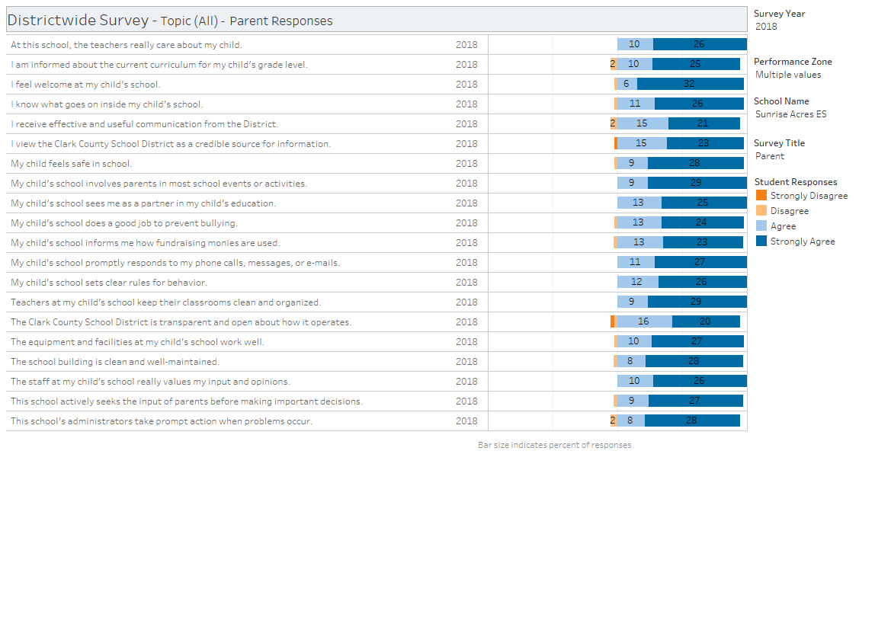
b. Survey Conclusions:
º Sunrise Acres had a low parent participation rate. For the 20182019 school year Districtwide Survey, the computers will be open and accessible for parents during the day to encourage them to take part in the survey. Staff will be on standby to assist with any questions or concerns. In order to notify parents about the survey, we will make announcements during Morning Ceremony, send out ParentLink messages, and hold Coffee with the Principal. Also, letters will be sent home notifying parent about this option.

- Hold monthly, weekly, or upon parent request, School Organizational Team (S.O.T.) and Title I Parent Meetings/Coffee with the Principal to inform parents about any revisions and, where applicable, implementation of School performance Plan and Victory grant.

- The Educational Involvement Accords are provided during the registration process on Infinite Campus. A copy of the Accord in English/Spanish will be sent home in the beginning of the year folder. During the initial Title I meeting ^{in} August, we will discuss its content with the families.
- Hold a minimum of one scheduled (the week of November 5, 2018) student led goal setting conference, where the following topics are discussed:
student progress, grade level curriculum, and assessment information.
7. Provide a Multicultural Night, a Literacy Night, and an Open House in the fall to increase parent's capacity for involvement in school to improve student academic achievement.
8. Encourage parents to visit the parent resource center, run in collaboration with the Public Education Foundation that encourages and supports parents with English, technology, and parenting classes. They also help parents schedule time in their child's classroom.

- Coordinate and integrate parent involvement programs and activities with pre-kinder programs available at the school site.
- Conduct Response to Instruction (RTI) meetings to plan classroom and home strategies and interventions for students not achieving CCSD benchmarks or program objectives,
11. Provide school newsletters in English and Spanish created by the Family Learning Action team, S.O.T. agendas and monthly meeting schedules are posted on our school website.
- Schedule and conduct Title I and/or Sunrise Acres Staff home visits by our school counselor, social worker, behavior strategist, and the Communities in Schools facilitator.
- Train staff on outreach, communication, and collaboration, through "Coffee and Culture," in regards to working with parents as equal partners in the educational process. The Family Learning Action Team led by teachers holds monthly meetings with parents to discuss improvement opportunities.
14. Facilitate parent participation in the development and revision of the school performance plan. Parents are included in discussions at “Coffee with the Principal” events and the open public comment period at SOT meetings.
15. Conduct parent surveys on the website and through written evaluations after all “Coffee with the Principal” events in order to gather parental feedback. Administration and the SOT analyze the results. The team makes recommendations to the principal. The principal conducts staff meetings and gathers input from staff members about concerns and ideas presented in the parent survey results. The principal works with the staff and the SOT on action plans to address concerns. The principal shares the action plans with parents and families during the “Coffee with the Principal” events. Parents and families can share their concerns at “Coffee with the Principal” events as well.
16. Utilize Infinite Campus and monitor closely to provide daily support by phone or letter to mitigate attendance problems.
Building the home-school connection through the various opportunities that will be provided to our families at Sunrise Acres will focus on developing our students as life-long learners and promote increased academic achievement in all core subjects.

